# SCIENTIFIC AND TECHNICAL INNOVATION COMPETITION

**2022-2023**

**\*\*\*\*\*\*\*\*\*\*\*\*\*\*\*\*\*\*\***

**SUMMARY REPORT**

**SCIENTIFIC AND TECHNICAL PROJECT**

**Topic name**

**COMMUNICATION SUPPORT APPLICATION FOR HEARING IMPAIRED PEOPLE USING AI TECHNOLOGY**

**Field: System software**

**Da Nang, October 2022.**

**TABLE OF CONTENTS**

**SCIENTIFIC AND TECHNICAL INNOVATION COMPETITION 1**

**I. INTRODUCTION 1**

1. Reason for choosing the topic 1

2. Research object 1

3. Research scope 1

4. Research purpose 1

**II. RESEARCH OVERVIEW 2**

1. Overview of sign language for deaf people 2

1.1. What is sign language? 2

1.2. Different sign languages in the world 2

1.3. Sign language in Vietnam 3

2.1. What is computer vision? 5

2.2. Intel OpenCV library 5

3. Existing solutions for deaf people in Vietnam 5

**III. METHODS OF IMPLEMENTATION 5**

1. Application construction basis 5

**IV. PRODUCT EXPERIMENT 9**

# I. INTRODUCTION

## 1. Reason for choosing the topic

According to statistics from the General Department of Population and Housing Statistics, as of early 2022, Vietnam currently has about 2.5 million deaf/hard of hearing people. Every year, around mid-September, the International Week of the Deaf (IWDP) and the International Day of Sign Language (IDSL) are held annually based on the founding date of the World Federation of the Deaf (WFD). – September 23, 1951) to create opportunities for deaf people to celebrate their community, language, culture and history; helps society know more about the local deaf community; and recognize the achievements of the deaf community. Although society has paid specific attention to the deaf community, they are still facing many obstacles when going for medical examination and treatment, when going through administrative procedures, going to markets, supermarkets... due to barriers. communicate. The use of sign language is an extremely necessary tool through which deaf people can integrate into the community. Based on the achievements and strong development of digital technology, we have actively researched and implemented the project: "COMMUNICATION SUPPORT APPLICATION FOR HEARING IMPAIRED PEOPLE USING AI TECHNOLOGY" with the desire partly support the difficulties of Vietnamese deaf people.

## 2. Research object

- Research on sign language for deaf people.

- Research on using programming languages to build applications released on smartphones.

- Research on hand gesture recognition technology (Hand Tracking) using OpenCV and Media Pipe in Python.

## 3. Research scope

- Sign language for people with disabilities according to Circular 17/2020/TT-BGDDT.

- Application for deaf people in Vietnam, works on computers and phones running Android or IOS operating systems.

## 4. Research purpose

Design an application that recognizes sign language using AI (artificial intelligence) technology, converts sign language into text, installs and can be used on computers and smartphones to support deaf people to communicate more easily with the community.

# II. RESEARCH OVERVIEW

## 1. Overview of sign language for deaf people

### 1.1. What is sign language?

Sign language is a language that uses hand expressions instead of voice sounds. Sign language was created by deaf people to help them communicate with each other in their community and absorb society's knowledge.

Like spoken language, the sign language of each country, even each region within a country, is very different. That is because each country and region has different history, culture, and customs, so the symbols to represent things and phenomena are also different. However, symbols everywhere in the world have certain similarities. For example, with the sign 'drink water', every country does the same thing by pretending to hold a cup to drink water, with the sign 'driving a car', pretending to hold the steering wheel of a car and turn it, etc. Every person (whether normal or deaf) has 30% of their sign language knowledge. Because sign language is more developed in the deaf/hard of hearing community, people from this community from two different countries can communicate with each other better than two normal people who do not know foreign languages.

### 1.2. Different sign languages in the world

| American Sign Language (ASL) | Indo-Pakistani Sign Language |
| --- | --- |
| * | Sign Language Pic Source: Google |

| Chinese Sign Language (CSL or ZGS) | Philippine Sign Language |
| --- | --- |
| https://tiengtrunganhduong.com/Images/images/ky%20hieu%20so%20dem%20tieng%20trung%20bang%20tay.jpg | http://www.aneking.com/wp-content/uploads/2015/04/Spanish_sign_language_alphabet.png |

### 1.3. Sign language in Vietnam

There are 6 methods of forming sign language in Vietnam:

- Direct pointing symbol

- Simulation symbols

- Reflecting characteristics or analyzing characteristics symbols

- Derivative symbols

- Borrowed symbols

- Letter and finger symbols

Table of alphabetic symbols, signs - bars, numbers and word symbols are regulated according to Circular 17/2020/TT BGDDT effective from September 1, 2020

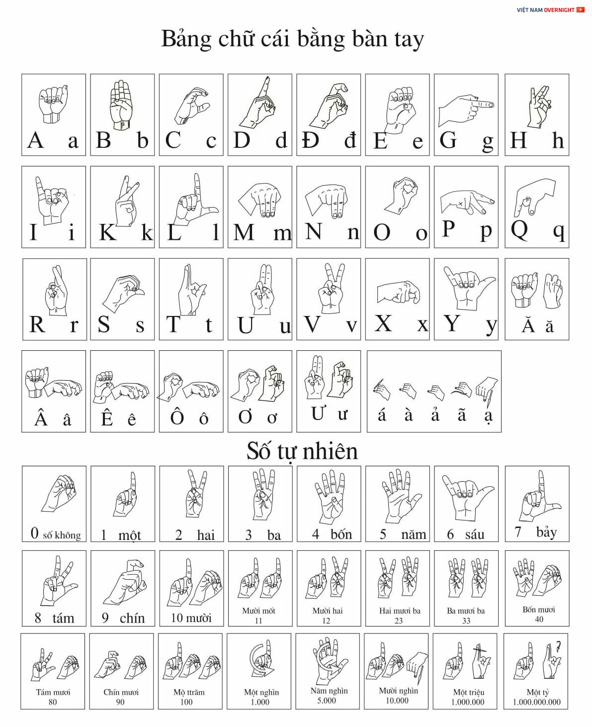

**2. Overview of computer vision**

### 2.1. What is computer vision?

Computer vision includes theory and related technical aspects aimed at creating an artificial system that can receive information from acquired images or multidimensional data sets.

### 2.2. Intel OpenCV library

Intel released OpenCV in 1999, which is a cross-platform open source computer vision library. OpenCV includes many advanced capabilities, which are the diversity of an artificial intelligence system. In addition, OpenCV also provides computer vision algorithm facilities through low application-level programming interfaces, which are packaged and completely free.

## 3. Existing solutions for deaf people in Vietnam

- Cochlear implant: only really effective when the child is implanted between 1 and 6 years old.

- Samsung's interpretation service to support the deaf/hard of hearing community was launched in November 2021, the customer support service in sign language is completely free.

- Chargeable Nang Moi sign language interpretation center.

- Applications to learn sign language, mainly American Sign Language (ALS - American Language Signal) on smartphones.

- Studies on hand movement recognition using Kinect sensors.

- Translation gloves: deaf and mute people will wear gloves with Flex Sensor and MPU6050 sensors, and perform learned gestures, the sensors on the gloves will receive electrical signals sent to the phone.

# III. METHODS OF IMPLEMENTATION

## 1. Application construction basis

- Python programming language to create an artificial intelligence model that recognizes hand language symbols.

- Dart programming language, flutter framework to build interfaces and features for applications.

- Open source library OpenCV (a set of software tools to process images, videos, and analyze input from cameras).

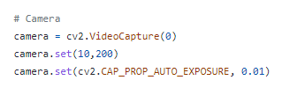

- Object detection algorithm to recognize hand symbols input from the camera.

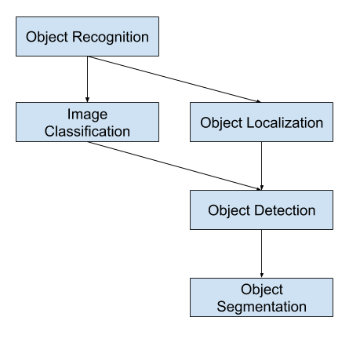

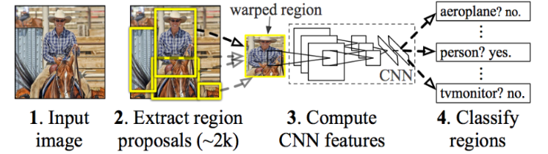

**2. Steps to build a customer identification application**

- Firstly, collect data to train the model (the brain of the machine learning model) by preparing input images of hands performing the above characters and saving them in the Data folder. These images are collected and filtered on a website specializing in supporting Data for data collection for an AI model called Kaggle. In addition, we also use images taken manually.

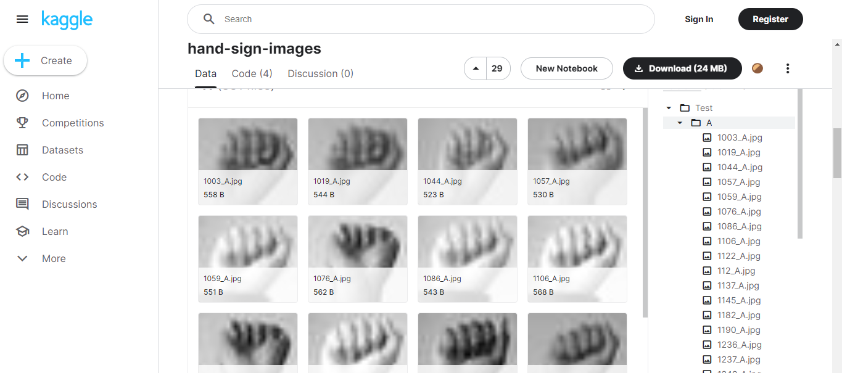

- Images are fully labeled with file names and converted to 224 x224 size.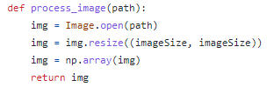

- Processing input data

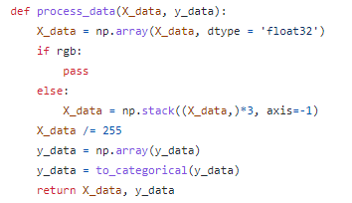

- After being labeled and sized, the data is input and divided into training and testing data at a ratio of 80% and 20%.

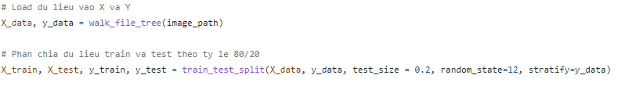

- Next, initialize and improve on a pretrained model named VGG16 by creating and adding a few Dense layers to increase accuracy when letting the model learn through data. Finally we will add a softmax layer to predict the output.

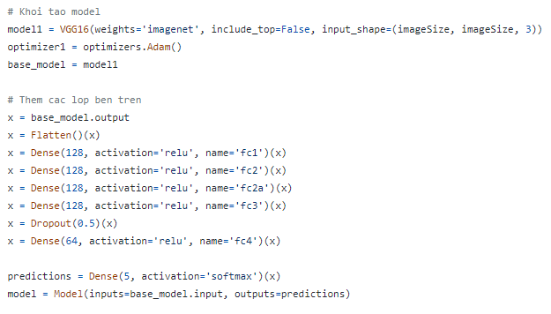

- Next, compile the model and select the number of times the model will train our data (epochs). The more training times, the greater the recognition accuracy.

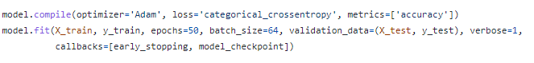

- Save the trained model to file



- After building the "brain" of the application, start training our network with more than 2000 training images and nearly 300 test images that have been prepared in advance.

“ python train_model.py “

- After training is completed, in the models folder, the file mymodel.h5 will appear, which is the saved model file.



- Then use the Dart programming language and its framework Flutter to build the interface and features for this application.

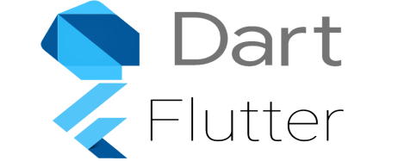

- Finally, put the model file we trained above into the above application interface to create a complete hand sign language recognition application product.



- Release and install on laptops and smartphones.

# IV. PRODUCT EXPERIMENT

1. Experiment at CDS Da Nang - Center for education and support for the deaf in the Central region

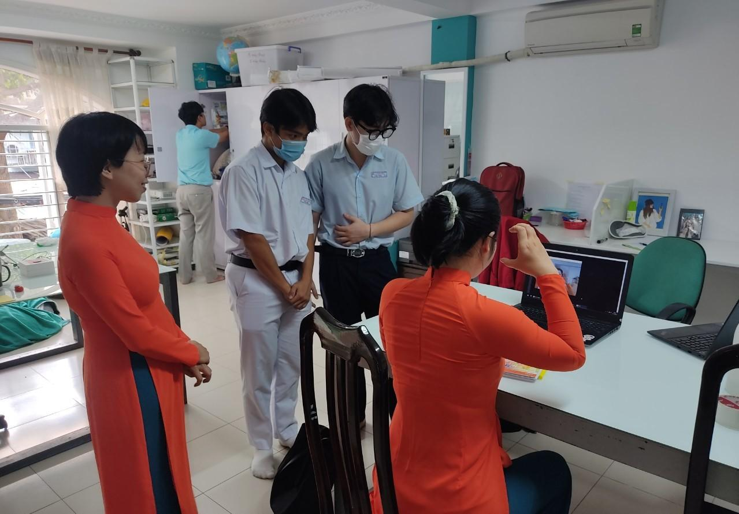

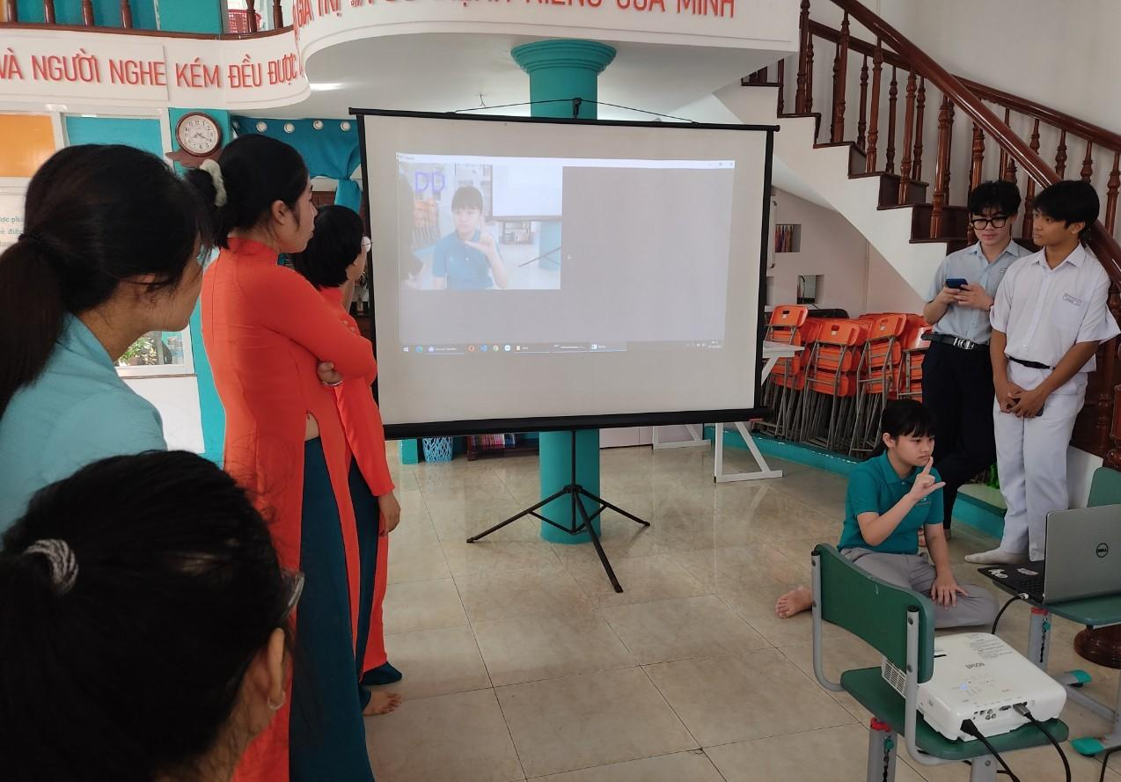

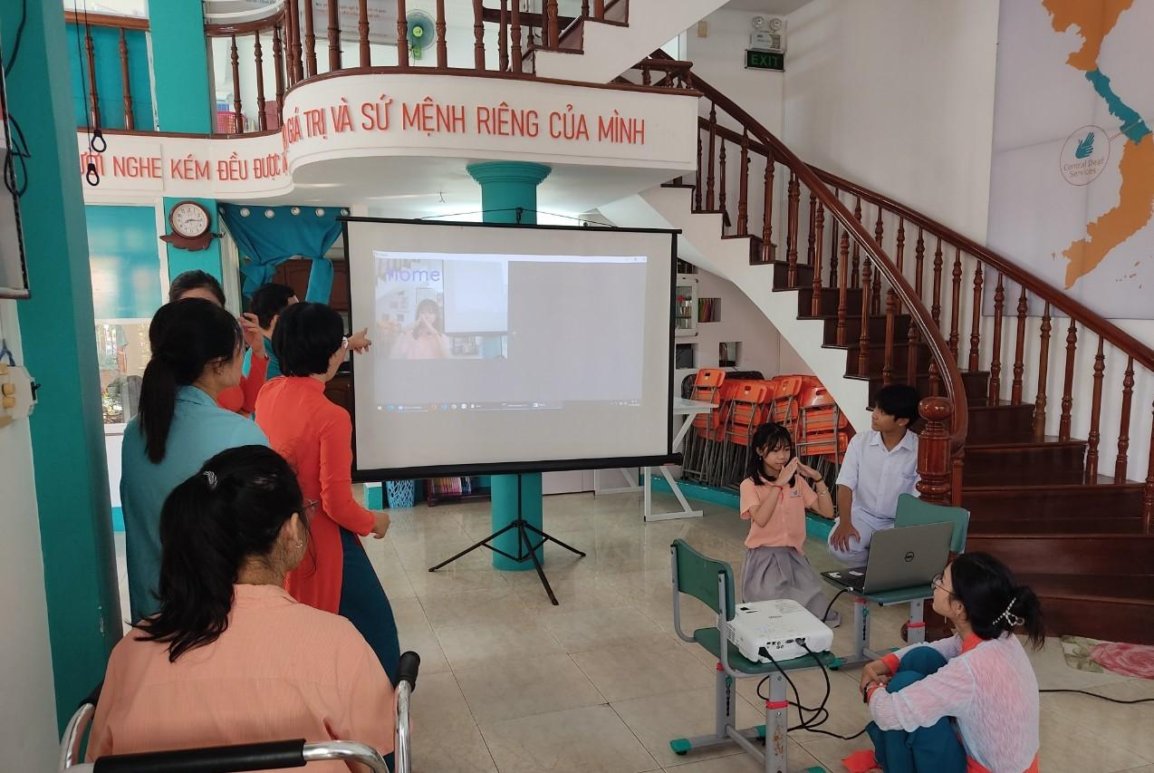

**V. CONCLUSION**

**1. Advantages of the application**

- Support deaf people, especially deaf children, to learn and communicate

- The application is completely free, easy to use and reaches many users

**2. Disadvantages of the application**

- Identification accuracy is not too high

- The interface is quite simple

- Running on a smartphone is not as stable as running on a computer

**3. Development direction of the research topic**

- Build and update new customer relations

- Develop an application to teach mathematical language for those who have never studied it

- Develop practical plans to help promote products to more users

- Build additional voice recognition support features so that deaf and normal people can communicate conveniently.

**REFERENCES**

Open CV source code library (https://opencv.org/)

Programming moblie applications with Dart and Flutter (https://codelearn.io/sharing/lap-trinh-mobile-dart-flutter-p1)

Standards on sign language for people with disabilities

Các chữ cái ngôn ngữ Việt Nam dành cho người khiếm thính